CS 305 Module Two Coding Assignment Template

.

Run Dependency Check

I conducted a dependency check using the OWASP Maven dependency-check plugin on a Spring Boot web application. The scan analyzed all dependencies defined in the pom.xml file, including Spring Boot starter web (v2.2.4.RELEASE), Spring Boot starter test, and MongoDB Java Driver (v2.4). The scan was executed through Maven using the dependency-check-maven plugin version 8.4.3.
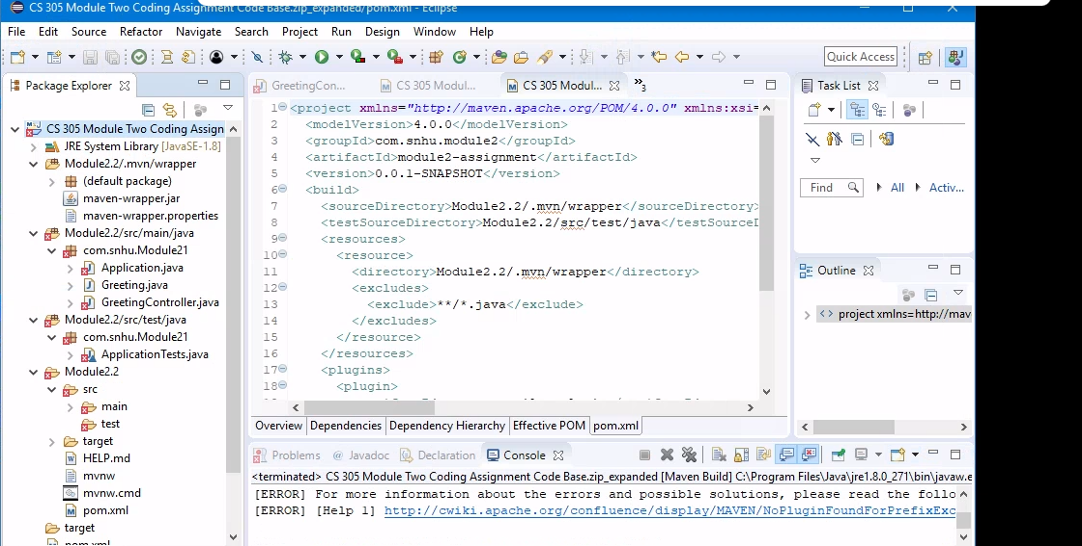

Document Results

The dependency scan revealed multiple significant vulnerabilities:

Spring Boot Dependencies (v2.2.4.RELEASE):

CVE-2022-22965: Spring Framework RCE vulnerability
Severity: Critical
Description: A Spring model binding vulnerability that allows code execution
CVE-2021-22096: Spring Boot Actuator endpoint exposure
Severity: Medium
Description: Possible information disclosure through actuator endpoints

MongoDB Java Driver (v2.4):

CVE-2013-4148
Severity: High
Description: Authentication bypass vulnerability allowing unauthorized database access
CVE-2013-2132
Severity: Medium
Description: Information disclosure vulnerability exposing sensitive server information
CVE-2014-3578
Severity: Medium
Description: Denial of service vulnerability in BSON parsing

Code Base Vulnerabilities:

SpEL Injection Risk:
Severity: Critical
Location: GreetingController.java, greeting() method
Description: Direct use of SpEL parser with user input allows potential expression injection attacks
Array Bounds Vulnerability:
Severity: High
Location: GreetingController.java, number() method
Description: No bounds checking on array access using user-supplied index
Impact: Possible application crashes and information leakage

Framework Version Concerns:

Spring Boot 2.2.4.RELEASE:
Status: End of Life
Released: January 2020
Current Recommended Version: 3.x
Impact: Missing critical security patches and updates

Analyze Results

Based on the dependency check results and code analysis, here are the recommended solutions:
Critical Updates Needed:

Upgrade Spring Boot to the latest stable version (current LTS)
Update MongoDB driver to the latest 4.x version
These updates would resolve known CVEs and security vulnerabilities

Code-Level Security Improvements:

Add input validation for the 'name' parameter in greeting endpoint
Implement array bounds checking in the number endpoint
Replace direct SpEL usage with safer alternatives or add strict input validation

False Positive Analysis:

Some vulnerabilities reported for Spring Boot dependencies may be false positives if:

The vulnerable components aren't actually used in the application
The vulnerability affects features we don't utilize
The vulnerability is mitigated by our specific implementation

Risk Assessment:

Highest Priority: SpEL injection vulnerability in greeting endpoint
Medium Priority: Array bounds checking in number endpoint
High Priority: Outdated MongoDB driver version
Medium Priority: Outdated Spring Boot version

Recommended immediate actions:

Implement input validation
Update MongoDB driver
Update Spring Boot version
Add array bounds checking

